Q1.

Part 1:

Minimum SOP:

$$AB+BC+\overline{A} \overline{B} \overline{C}$$

Actual Expression:

$$ABC+\overline{A}BC+AB\overline{C}+\overline{A} \overline{B} \overline{C}$$

Truth Table:

|  |  |  |  |  |  |  |  |  |  |  |
| --- | --- | --- | --- | --- | --- | --- | --- | --- | --- | --- |
| A | B | C | A’ | B’ | C’ | ABC | A’BC | ABC’ | A’B’C’ | F |
| 0 | 0 | 0 | 1 | 1 | 1 | 0 | 0 | 0 | 1 | 1 |
| 0 | 0 | 1 | 1 | 1 | 0 | 0 | 0 | 0 | 0 | 0 |
| 0 | 1 | 0 | 1 | 0 | 1 | 0 | 0 | 0 | 0 | 0 |
| 0 | 1 | 1 | 1 | 0 | 0 | 0 | 1 | 0 | 0 | 1 |
| 1 | 0 | 0 | 0 | 1 | 1 | 0 | 0 | 0 | 0 | 0 |
| 1 | 0 | 1 | 0 | 1 | 0 | 0 | 0 | 0 | 0 | 0 |
| 1 | 1 | 0 | 0 | 0 | 1 | 0 | 0 | 1 | 0 | 1 |
| 1 | 1 | 1 | 0 | 0 | 0 | 1 | 0 | 0 | 0 | 1 |

Actual :

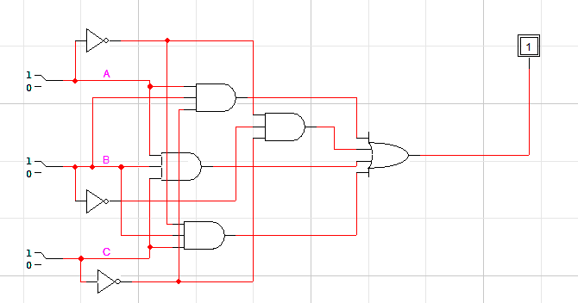

Reduced:

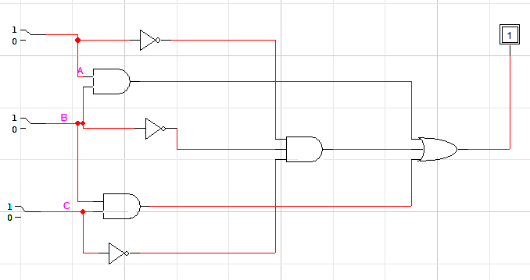

Part 2:

Minimum SOP:

$$AC+\overline{B}+\overline{A} \overline{C}$$

Actual Expression:

$$ABC+\overline{A} \overline{B}\overline{C}+\overline{A}B\overline{C}+A\overline{B} \overline{C}+A\overline{B}C+\overline{A} \overline{B}C$$

Truth Table:

|  |  |  |  |  |  |  |  |  |  |  |  |  |
| --- | --- | --- | --- | --- | --- | --- | --- | --- | --- | --- | --- | --- |
| A | B | C | A’ | B’ | C’ | ABC | A’BC’ | AB’C’ | AB’C | A’B’C | A’B’C’ | F |
| 0 | 0 | 0 | 1 | 1 | 1 | 0 | 0 | 0 | 0 | 0 | 1 | 1 |
| 0 | 0 | 1 | 1 | 1 | 0 | 0 | 0 | 0 | 0 | 1 | 0 | 1 |
| 0 | 1 | 0 | 1 | 0 | 1 | 0 | 1 | 0 | 0 | 0 | 0 | 1 |
| 0 | 1 | 1 | 1 | 0 | 0 | 0 | 0 | 0 | 0 | 0 | 0 | 0 |
| 1 | 0 | 0 | 0 | 1 | 1 | 0 | 0 | 1 | 0 | 0 | 0 | 1 |
| 1 | 0 | 1 | 0 | 1 | 0 | 0 | 0 | 0 | 1 | 0 | 0 | 1 |
| 1 | 1 | 0 | 0 | 0 | 1 | 0 | 0 | 0 | 0 | 0 | 0 | 0 |
| 1 | 1 | 1 | 0 | 0 | 0 | 1 | 0 | 0 | 0 | 0 | 0 | 1 |

Actual :

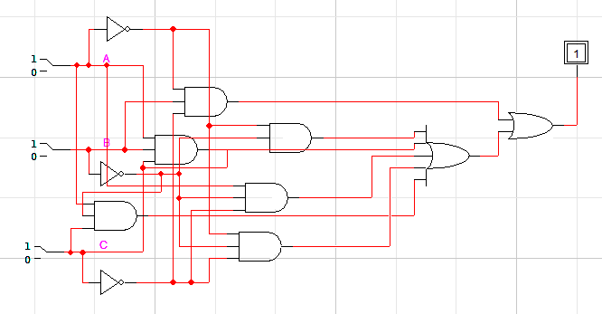

Reduced:

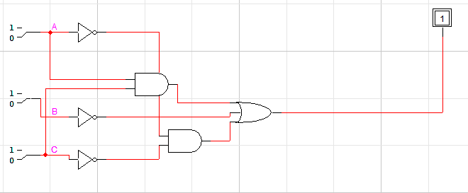

Q2.

Part 1:

$$(A+B+\overline{C})(\overline{A}+\overline{B}+\overline{C}+\overline{D})(\overline{A}+D)$$

Part 2:

$$(A+B+\overline{D})(A+\overline{C}+\overline{D})(\overline{B}+\overline{C}+\overline{D})(B+C+\overline{D})$$

Q3.

|  |  |  |
| --- | --- | --- |
| C  AB | 0 | 1 |
| 00 | 1 | 1 |
| 01 |  | 1 |
| 11 |  |  |
| 10 | 1 | 1 |

Minimized SOP:

$$\overline{B}+\overline{A}C$$

Truth Table:

|  |  |  |  |  |  |  |
| --- | --- | --- | --- | --- | --- | --- |
| A | B | C | A’ | B’ | A’C | F |
| 0 | 0 | 0 | 1 | 1 | 0 | 1 |
| 0 | 0 | 1 | 1 | 1 | 1 | 1 |
| 0 | 1 | 0 | 1 | 0 | 0 | 0 |
| 0 | 1 | 1 | 1 | 0 | 1 | 1 |
| 1 | 0 | 0 | 0 | 1 | 0 | 1 |
| 1 | 0 | 1 | 0 | 1 | 0 | 1 |
| 1 | 1 | 0 | 0 | 0 | 0 | 0 |
| 1 | 1 | 1 | 0 | 0 | 0 | 0 |

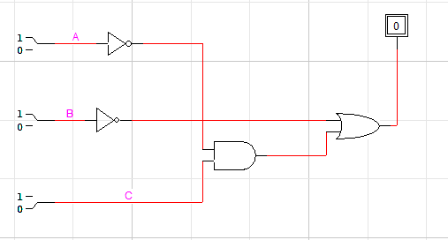

Q4.

|  |  |  |  |  |
| --- | --- | --- | --- | --- |
| CD  AB | 00 | 01 | 11 | 10 |
| 00 | 1 | 0 | 1 | 1 |
| 01 | 1 | 0 | 0 | 1 |
| 11 | 1 | 0 | 0 | 1 |
| 10 | 0 | 0 | 1 | 1 |

Minimized SOP:

$$\overline{A} \overline{D}+B\overline{C} \overline{D}+\overline{B}C+C\overline{D}$$

Truth Table:

|  |  |  |  |  |  |  |  |  |  |  |  |  |
| --- | --- | --- | --- | --- | --- | --- | --- | --- | --- | --- | --- | --- |
| A | B | C | D | A’ | B’ | C’ | D’ | A’D’ | BC’D’ | B’C | CD’ | F |
| 0 | 0 | 0 | 0 | 1 | 1 | 1 | 1 | 1 | 0 | 0 | 0 | 1 |
| 0 | 0 | 0 | 1 | 1 | 1 | 1 | 0 | 0 | 0 | 0 | 0 | 0 |
| 0 | 0 | 1 | 0 | 1 | 1 | 0 | 1 | 1 | 0 | 1 | 1 | 1 |
| 0 | 0 | 1 | 1 | 1 | 1 | 0 | 0 | 0 | 0 | 1 | 0 | 1 |
| 0 | 1 | 0 | 0 | 1 | 0 | 1 | 1 | 1 | 1 | 0 | 0 | 1 |
| 0 | 1 | 0 | 1 | 1 | 0 | 1 | 0 | 0 | 0 | 0 | 0 | 0 |
| 0 | 1 | 1 | 0 | 1 | 0 | 0 | 1 | 1 | 0 | 0 | 1 | 1 |
| 0 | 1 | 1 | 1 | 1 | 0 | 0 | 0 | 0 | 0 | 0 | 0 | 0 |
| 1 | 0 | 0 | 0 | 0 | 1 | 1 | 1 | 0 | 0 | 0 | 0 | 0 |
| 1 | 0 | 0 | 1 | 0 | 1 | 1 | 0 | 0 | 0 | 0 | 0 | 0 |
| 1 | 0 | 1 | 0 | 0 | 1 | 0 | 1 | 0 | 0 | 1 | 1 | 1 |
| 1 | 0 | 1 | 1 | 0 | 1 | 0 | 0 | 0 | 0 | 1 | 0 | 1 |
| 1 | 1 | 0 | 0 | 0 | 0 | 1 | 1 | 0 | 1 | 0 | 0 | 1 |
| 1 | 1 | 0 | 1 | 0 | 0 | 1 | 0 | 0 | 0 | 0 | 0 | 0 |
| 1 | 1 | 1 | 0 | 0 | 0 | 0 | 1 | 0 | 0 | 0 | 1 | 1 |
| 1 | 1 | 1 | 1 | 0 | 0 | 0 | 0 | 0 | 0 | 0 | 0 | 0 |

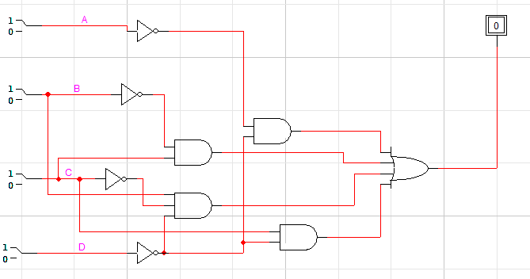

POS Expression:

$$\overline{C}D+BD+A\overline{B} \overline{C}$$

